MPCA: Lab - 8

Name: Rithvik
SRN: PES2UG23CS485
Sec: H

- Use PARACACHE SIMULATOR for the exercise below given the following configuration .
  - Cache Size: 32 words
  - Memory Size: 131072 words[main memory].
  - Block Size: 4 words.
Use Write back policy
Also, repeat the exercise for Write through policy.
Include One Screenshot(for Write Back Cache) with
i) Cache Address Table showing the splitup of the address fields for the requests generated by the processor
ii) Screenshot showing the Cache Table
iii) Screenshot showing hit and miss rates

Include One Screenshot(for Write Through Cache) with
i) Cache Address Table showing the splitup of the address fields for the requests generated by the processor
ii) Screenshot showing the Cache Table
iii) Screenshot showing hit and miss rates

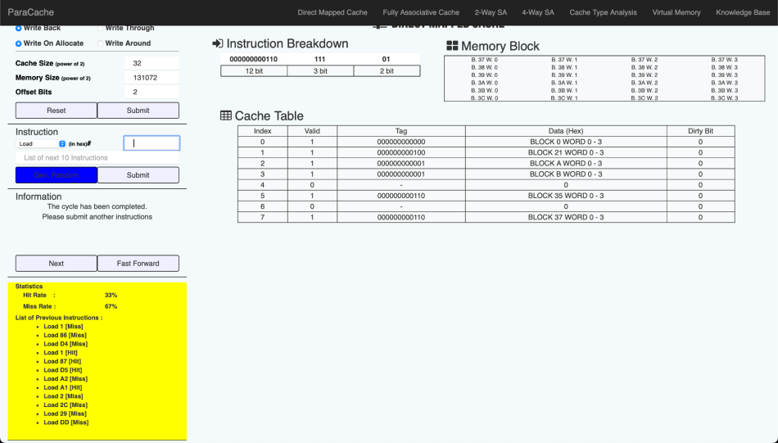
a) Direct Mapped (With Write-Through Policy)
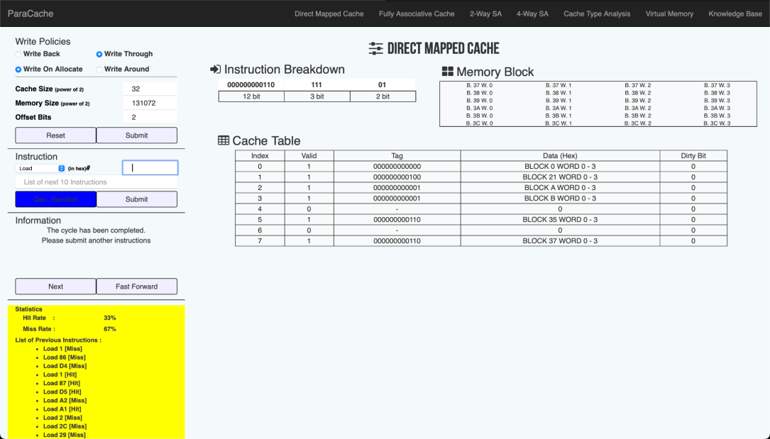
a) Fully Associative (With Write-Back Policy)
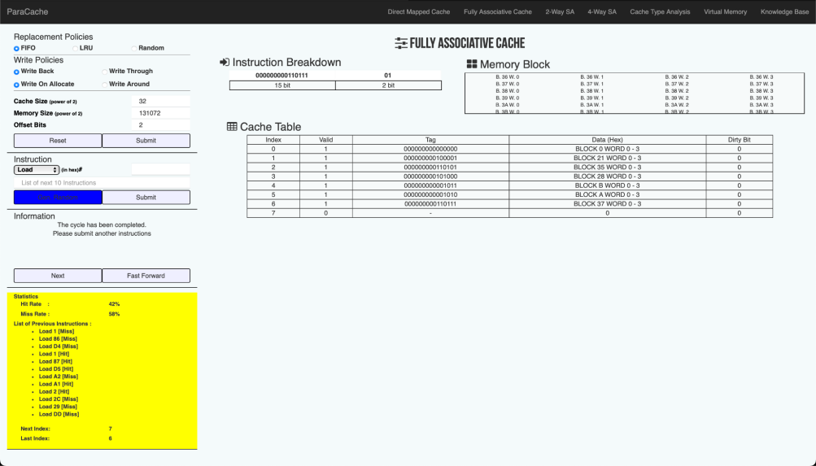
a) Fully Associative (With Write-Through Policy)
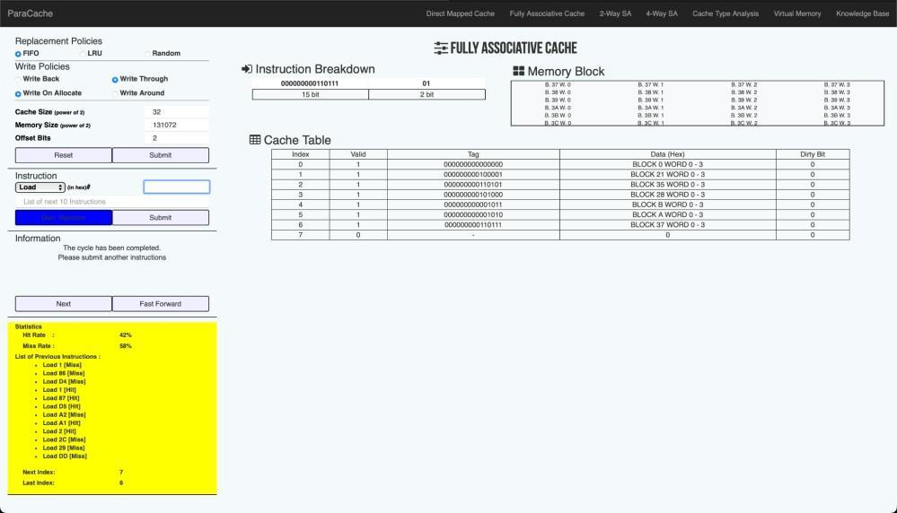
- 2 Way-Set Associative (With Write-Back Policy)
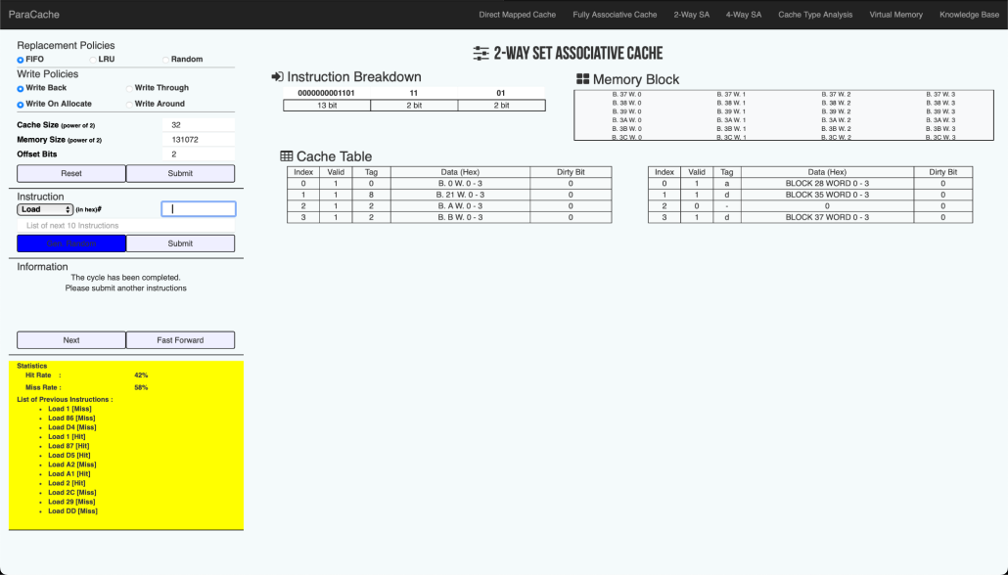
- 2 Way-Set Associative (With Write-Through Policy)
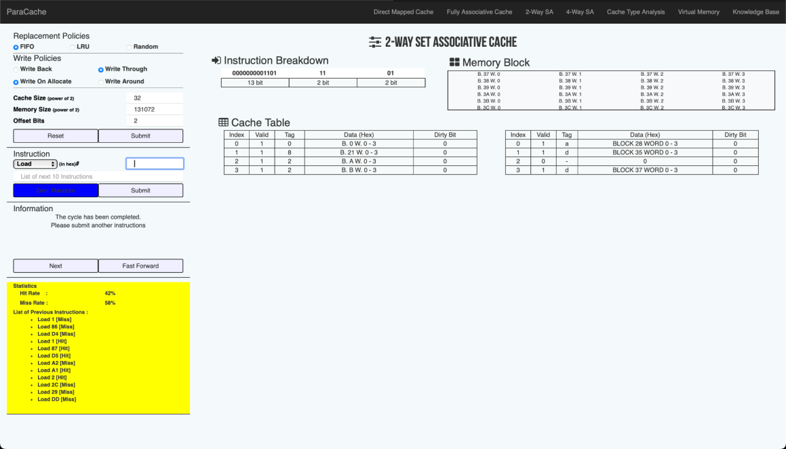
- Direct Mapped (With Write-Back Policy)
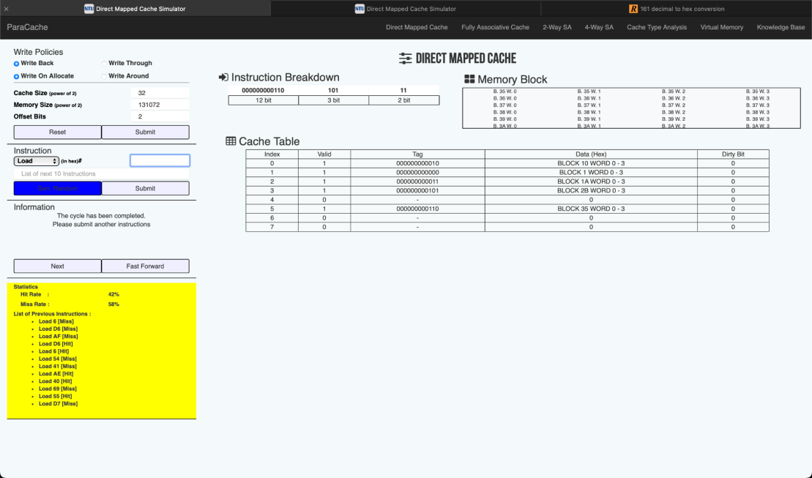
b) Direct Mapped (With Write-Through Policy)
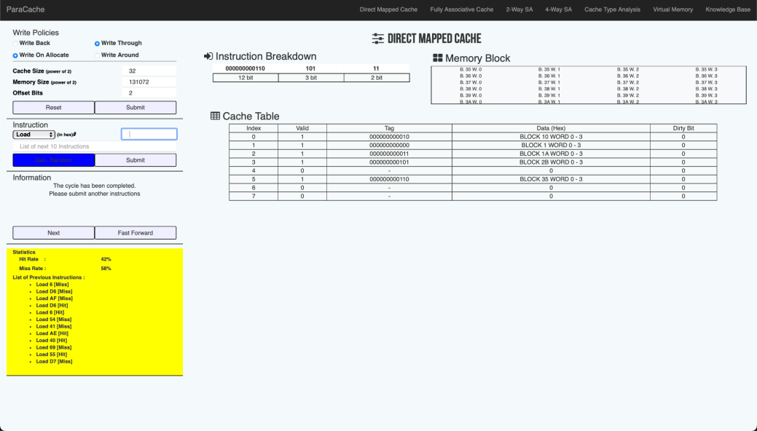
b) Fully Associative (With Write-Back Policy)
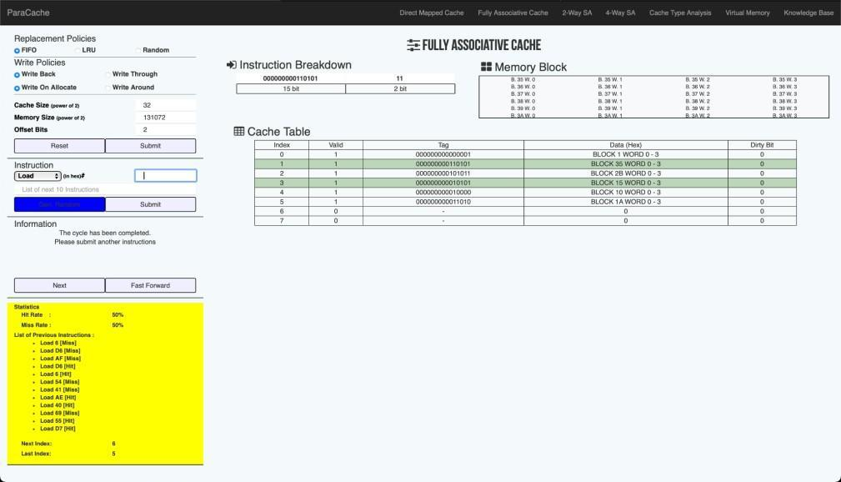
b) Fully Associative (With Write-Through Policy)
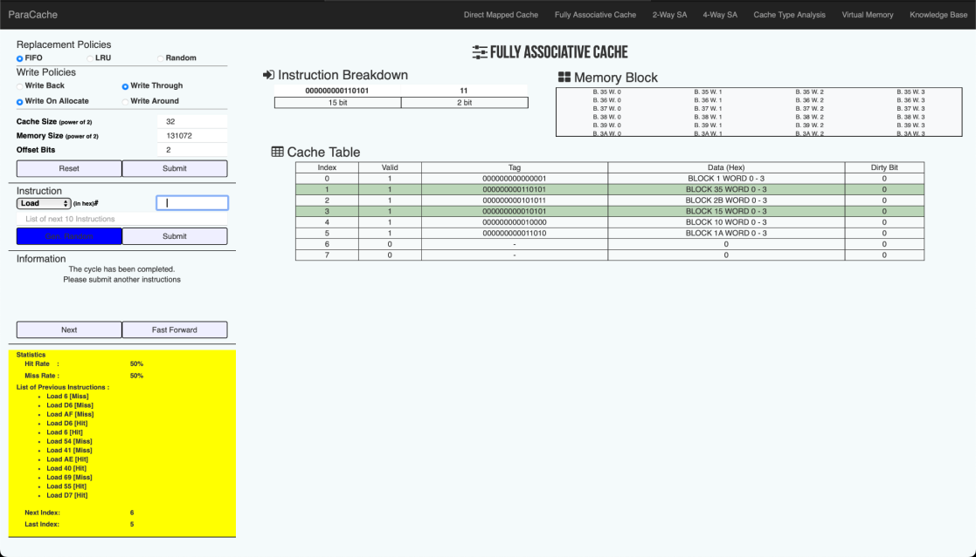
b) 2 Way-Set Associative (With Write-Back Policy)
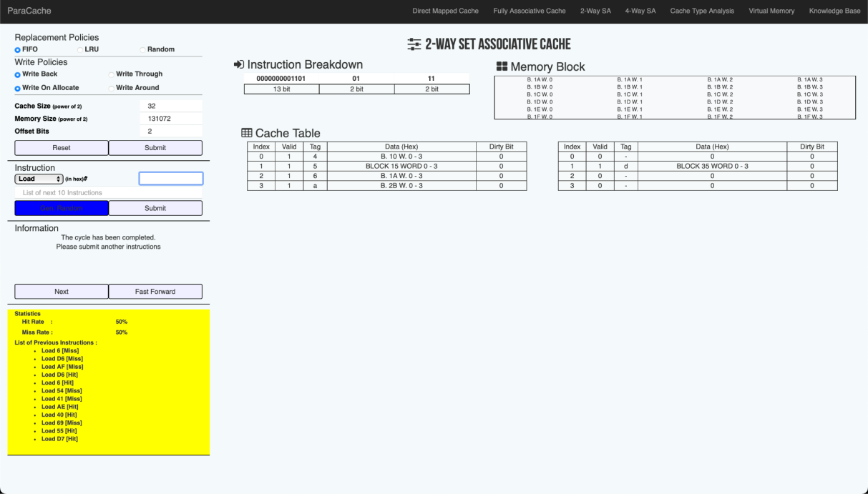
b) 2 Way-Set Associative (With Write-Through Policy)
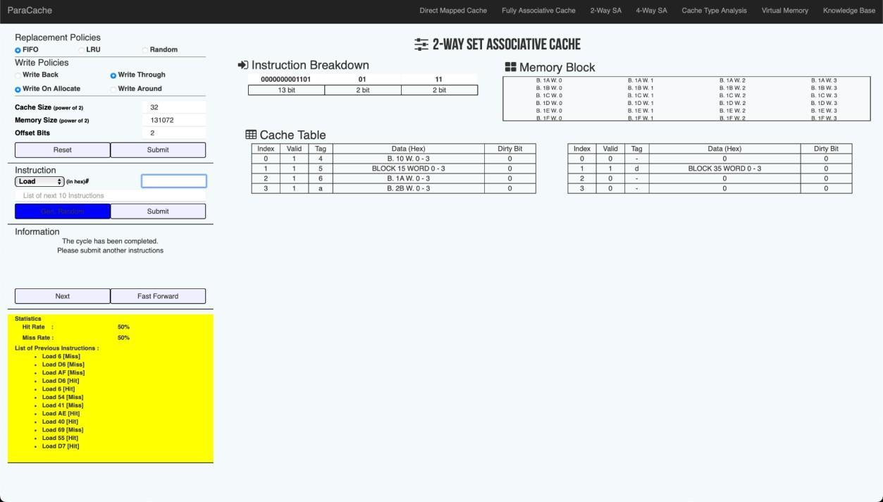

2. Below is a list of 32-bit memory address references, given as word addresses.
i)1, 134, 212, 1, 135, 213, 162, 161, 2, 44, 41, 221
ii) 6, 214, 175, 214, 6, 84, 65, 174, 64, 105, 85, 215

i. For each of the references, identify the binary address, the tag, and the index given a direct-mapped cache with 16 one-word blocks. Also, list if each reference is a hit or a miss, assuming the cache is initially empty.
a) Direct Mapped:
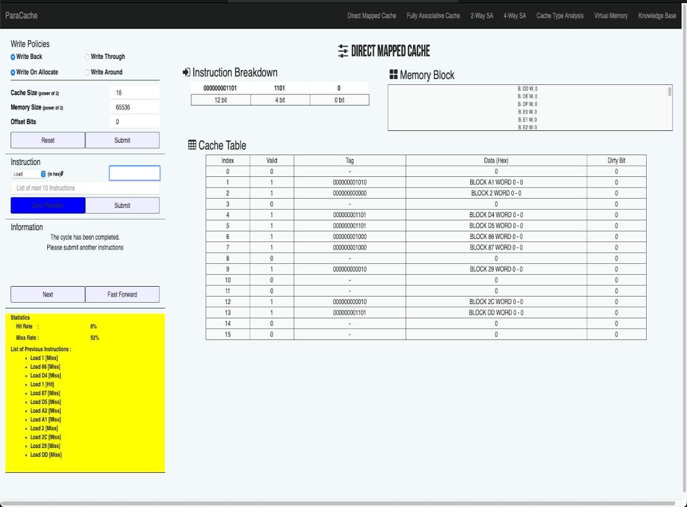
b) Direct Mapped:

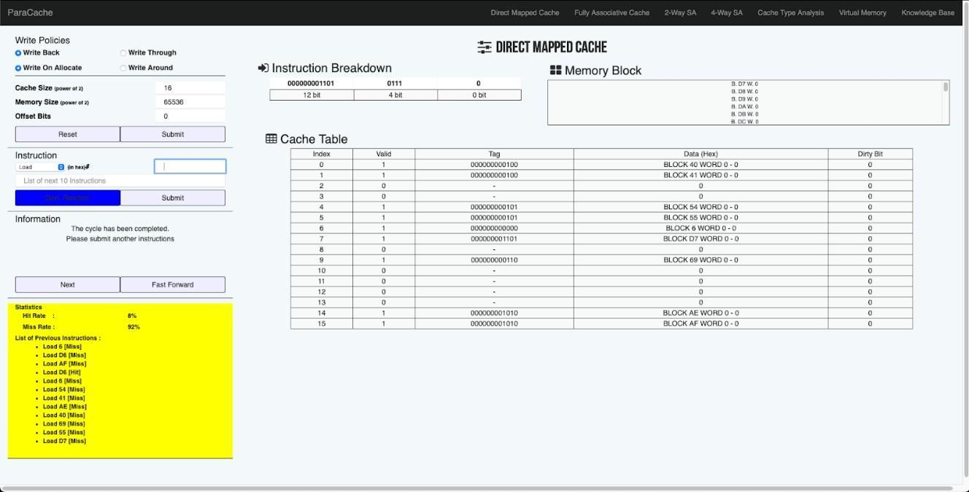

ii. Repeat the exercise mentioned in case (i) with 2-word blocks and a total size of eight blocks for set associative and fully associative cache mapping.
What is the hit rate and miss rate?
Also Explore replacement algorithm FIFO and LRU
Ans) a) Fully Associative
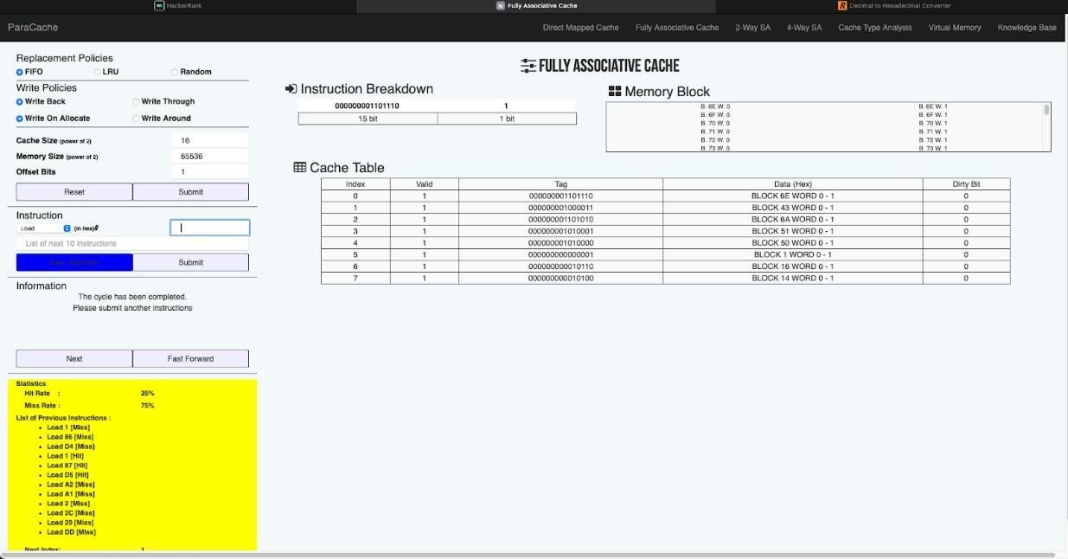
    - 2 Way-Set Associative
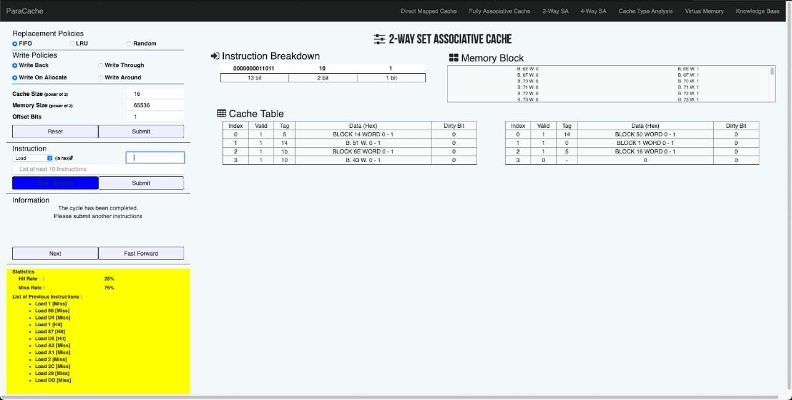
    - Fully Associative
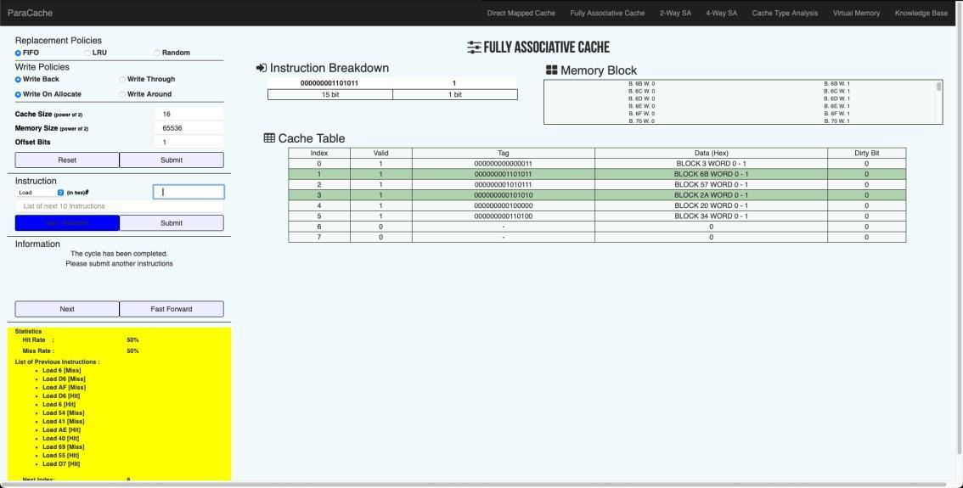
- 2 Way-Set Associative
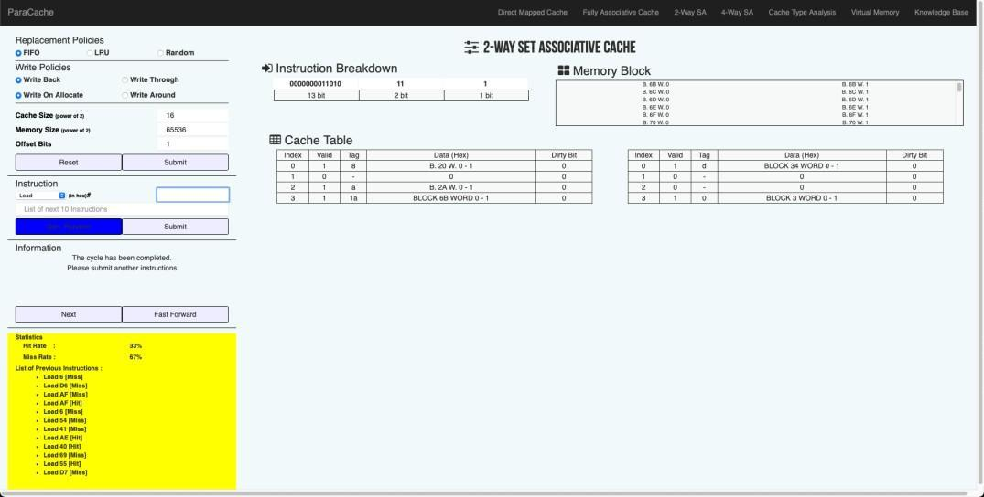

3. Try using PARACACHE SIMULATOR for the exercise for the following configuration .
Cache Size: 32 words
Memory Size: 16-bit memory address
Block Size: 16 words.
Use Write back policy
Also, repeat the exercise for Write through policy.

Include One Screenshot for each case with
i) Cache Address Table showing the splitup of the address fields for the requests generated by the processor
ii) Screenshot showing the Cache Table
iii) Screenshot showing hit and miss rates
a) Write back:
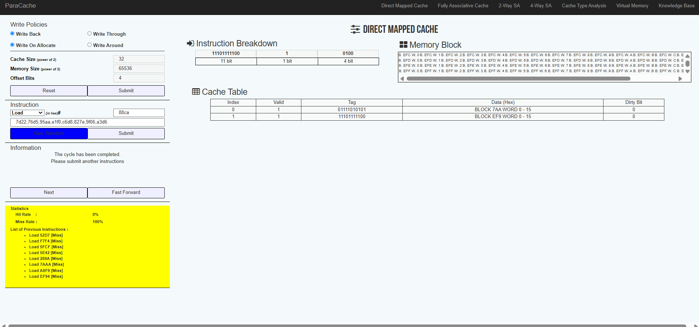

b) Write through:
